CN
1.Switch, Router and hub which layer works and differentiate it?
Hub works in physical layer
Switch works in data link layer
Router works in network layer
Hub-> it broad cast data to all interconnected devices it doesn’t filter ex: office network
Switch -> it forward data to the intended devices based on mac address ex: network switch
Router -> it routes the data through the network using IP address
2.Give examples of some protocols?
HTTP -> Transferring the webpages ex: loading website.
HTTPS -> secure http by encrypting data. Ex: online banking app.
FTP -> Transferring files between the systems Ex: uploading files to server.
ICMP -> It provides error message. and provide how to resolve the problem (manuals) network diagnostics. Ex: pinging a server.
DHCP -> IT assigns an IP address dynamically to a device on a network ex: connecting Wi-Fi
SMTP -> send and receive mail Ex: send a mail from the client to mail server.
POP3 -> Doesn’t store email in server
3. ICMP uses a ping command. This command diagnostics the connecting issues by sending echo request and it measures a response time.
Multicasting and broadcasting
Multicasting: send a data to specific group of devices or host(client) ex: send video stream to group of devices/people
Broadcasting: send data to all the devices on the network ex: chat application (broadcast channel) other example DHCP server assign the IP address to all the devices that relates to the same network.
4.Why TCP is connection oriented?
Connection orientation means that the communicating devices should establish a connection before transmitting data and should close the connection after transmitting the data.
TCP connection is a bytestream, and UDP is a message stream
TCP -> uploaded videos of YouTube
UDP -> Video call, online gaming, skype, zoom meeting

5.If UDP is not reliable, why do we use it?
UDP is used in applications requiring low latency and minimal overhead, such as video streaming (e.g., YouTube Live), online gaming (e.g., Fortnite), VoIP (e.g., Skype), DNS (e.g., domain name lookups), and live broadcasts (e.g., Twitch).
HOW UDP handles out of packet?
Three way hand shaking?
what do you understand by data recovery and disaster management?
tcp and udp? difference?
what is icmp protocol?
how does ping works? explain the entire flow?
difference between ip and mac address?
http, ftp , telnet?
osi layer detailed explaination?
how do you design search engine from scratch?
bus topology?
broadcasting type transmission that occurs?
iso and osi model?
a situation where you re a before login page and you have to login with user id and password once verified ok you have to upload 5 mb file draw usecase diagram demonstrate from login to uploading file . what happens detailly at os and network layer?
explain how webbrowser retrie data from server when url is loaded?
what is cookies?
what is section data?
local storage?
what is cache?
what is web security?
what is the difference btw authentication and authorization?
what is dom? how it i s used in web development?
copy and paste or cut and paste which is fast?
how do you ensure to have min latency?
how does https work?
Connection orientation means that the communicating devices should establish a connection before transmitting data and should close the connection after transmitting the data.
If UDP is not reliable, why do we use it?"
Candidate: "UDP is used in applications requiring low latency and minimal overhead, such as video streaming (e.g., YouTube Live), online gaming (e.g., Fortnite), VoIP (e.g., Skype), DNS (e.g., domain name lookups), and live broadcasts (e.g., Twitch).
Define network?
A network is a collection of interconnected devices (such as computers, servers, smartphones, routers, switches, etc.) that communicate with each other to share data and resources through physical or wireless connections. Example of a Network: The Internet:

Key Components of a Network:
• Nodes: Devices connected to the network (e.g., computers, phones, printers).
• Links: The physical or logical connections that allow data to travel between nodes (e.g., cables, wireless signals).
• Protocols: Rules and standards that govern how data is transmitted across the network (e.g., TCP/IP, HTTP, FTP).
• Switches/Routers: Devices that direct traffic between different devices or networks.
Types of Networks
A computer network can transmit data by two methods-
1) Point-to-Point: A dedicated communication channel or link connects 2 devices. The two connected devices use the full capacity of the channel as no other devices are connected.
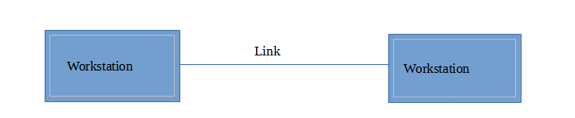
2)Multipoint (Broadcast): More than two devices share a single link. Channel capacity is shared between connected devices.
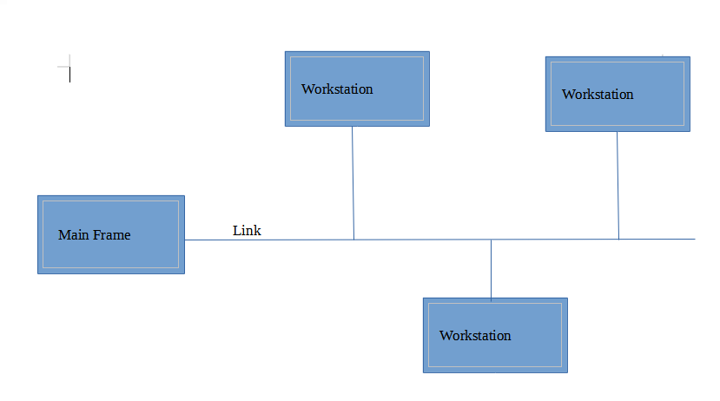
What do you mean by network topology, and explain types of them?

